 **MATHEMATICS APPLICATIONS**

**Test 4 2018 Statistics**

**Section A-Resource Free**

**Marks: 20 Time Allowed: 20 minutes**

**TOTAL : 57 Name: _______________**

**ALL** working must be shown for full marks.

**For any answers that do not exist an explanation must be given.**

**Question 1** **[4 marks]**

1. Classify the following data by placing it into the correct section of the table:

Times recorded in a running race, car colours, baby weight, gender, hotel star rating, number of goals kicked in a football game, report grades, height, language spoken at home.

|  |  |  |  |
| --- | --- | --- | --- |
| **Categorical** | | **Numerical** | |
| **Nominal** | **Ordinal** | **Discrete** | **Continuous** |
|  |  |  |  |
|  |  |  |  |
|  |  |  |  |

**Question 2 [4, 4 = 8 marks]**

Calculate the mean, median, mode and range for the following sets of data.

1. 3, 7, 10, 3, 11, 0, 6, 8
2. 1 3, 6

2 0, 4, 7

3

4 0, 9

5 1, 2, 8

**Question 3 [3, 5 = 8 marks]**

1. Given the set of nine scores below, give a possible value for a 10th score **x** if it is a maximum score and an outlier. Justify your answer by showing all calculations.

16, 5, 7, 3, 12, 20, 16, 11, 2, **x**

1. Describe how removing the outlier above will **affect** the
2. Mean
3. Median
4. Mode
5. Standard deviation
6. Range



**MATHEMATICS APPLICATIONS**

**Test 4 2018 Statistics**

**Section B-Resource Assumed**

**Marks: 37 Time Allowed: 35 minutes**

**ALL** working must be shown for full marks.

**Question 1 [1, 2, 5, 4 = 12 marks]**

The following dot plot represents the number of pizza slices eaten per person at a teenager’s

16th 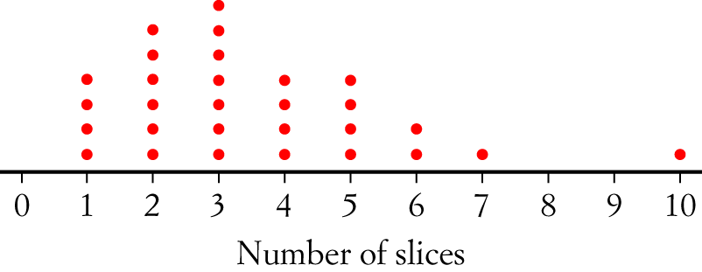birthday.

1. What is the total number of pizza slices consumed?
2. Is 10 an outlier? Explain.
3. Ignoring any outliers, calculate the Mean, Mode, Median and Range and Inter Quartile Range for the number of slices of pizza eaten.
4. Create a Box and whisker graph below using the statistics in part **c)**

**Question 2** **[ 3, 2, 1 = 6 marks]**

The sixty Mathematics students at City Senior High School sat for a Data Analysis test.

The table below shows the results on the test, which was marked out of 50.

|  |  |
| --- | --- |
| Marks *(x)* | Number of students *(n* |
| 10  *x* < 20 | 26 |
| 20  *x* < 30 | 19 |
| 30  *x* < 40 | 11 |
| 40  *x* < 50 | 3 |
| *x*50 | 1 |

1. Plot this information as a histogram on the grid below.
2. Use a horizontal line to show the location the Mean and Median on the histogram below.

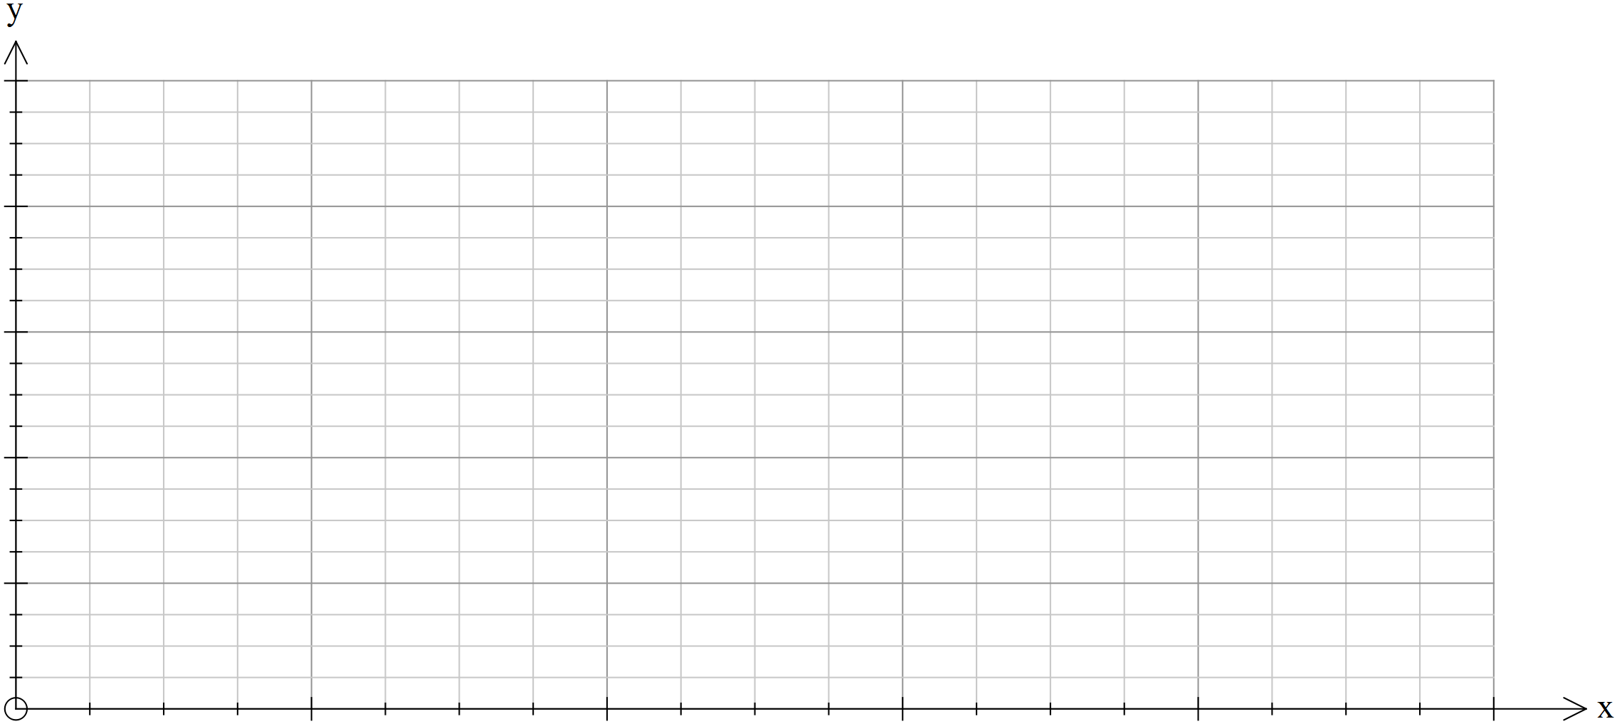

1. Describe the shape of the histogram you have drawn.

**Question 3** **[1, 1, 1, 2 = 5 marks]**

The following boxplot shows the amount of pocket money ($) children were paid per month.

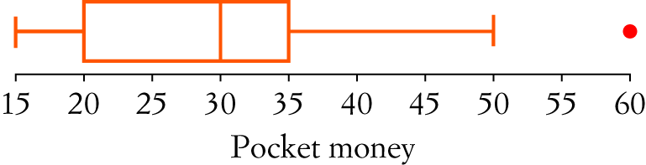

1. What is the median pocket money paid?
2. What percentage of children were given pocket money of $35 dollars or less?
3. What is represented by the dot at the end of the graph?
4. Describe the data found in the box plot.

**Question 4** **[4 marks]**

The scores below are in ascending order and have a median of 26, a range of 38 and an interquartile range of 28. Find the values of **a**, **b** and **c**.

**a**, 6, 10, 22, **b**, 28, **c**, 38, 40.

**Question 5 [5, 3, 2 = 10 marks]**

The data below shows the English essay results out of 50 for two different classes.

1. Calculate the mean, mode, median, IQR and standard deviation for each class.

|  |  |
| --- | --- |
| **Class A Results** | **Frequency** |
| 20-29 | 4 |
| 30-39 | 5 |
| 40-49 | 6 |
| 50-59 | 5 |
| 60-69 | 5 |
| 70-79 | 3 |
| 80-89 | 4 |

|  |  |
| --- | --- |
| **Class B Results** | **Frequency** |
| 20-29 | 2 |
| 30-39 | 1 |
| 40-49 | 7 |
| 50-59 | 11 |
| 60-69 | 10 |
| 70-79 | 0 |
| 80-89 | 1 |

Mean: Mean:

Mode: Mode:

Median: Median:

IQR: IQR:

St Dev (sx) : St Dev (sx):

1. Comment on the results for each class and how they compare.
2. Calculate the mean and standard deviation for the combined group A and B and use the information below to calculate the number of A’s and B’s for the combined group.

A- given to any mark 1.5 standard deviations above the mean.

B- given to any mark between 0.5 and 1.5 standard deviations above the mean.

C- given to any mark between 0.5 standard deviations above or below the mean.

D- given to any mark between 0.5 and 1.5 standard deviations below the mean.

E- given to any mark 1.5 standard deviations below the mean.